Nonagonal Cupola

Definition
# Source: AI Source: Provided by: [Data Path: Persons Table -> ID Column: 1, Name_En Column: Motasem Essam] -> From: [ChatGPT] on [7/25/2026]
A Nonagonal Cupola is a polyhedron consisting of a regular nonagonal upper base (9 sides) and a regular octadecagonal lower base (18 sides).
The two parallel bases are connected by alternating 9 triangular faces and 9 square faces in the regular cupola arrangement.
It belongs to the family of $n$-gonal cupolas, where $n=9$.
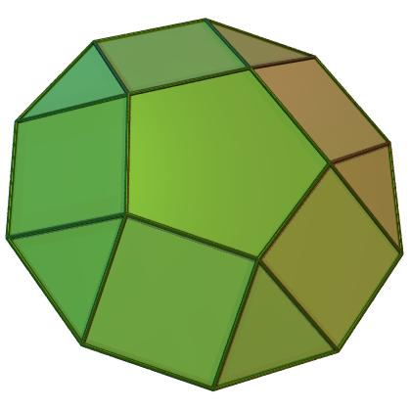

Simple Definition
# Source: AI Source: Provided by: [Data Path: Persons Table -> ID Column: 1, Name_En Column: Motasem Essam] -> From: [ChatGPT] on [7/25/2026]
A Nonagonal Cupola is a solid with:
- One nonagonal upper base (9 sides).
- One octadecagonal lower base (18 sides).
- 9 triangular lateral faces.
- 9 square lateral faces.
- 20 faces in total.
- 45 edges.
- 27 vertices.

Geometric Structure
# Source: AI Source: Provided by: [Data Path: Persons Table -> ID Column: 1, Name_En Column: Motasem Essam] -> From: [ChatGPT] on [7/25/2026]
The Nonagonal Cupola consists of two parallel polygonal bases:
- Upper Base: A regular nonagon with 9 sides.
- Lower Base: A regular octadecagon with 18 sides.
- Central Axis: Passes through the centers of both bases and is perpendicular to their planes.
- Lateral Surface: Connects the two bases through alternating triangular and square faces.
The 9 upper vertices correspond to alternating vertices of the lower octadecagon, creating the characteristic cupola arrangement.
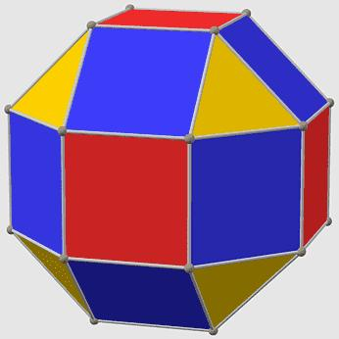

Face Structure
# Source: AI Source: Provided by: [Data Path: Persons Table -> ID Column: 1, Name_En Column: Motasem Essam] -> From: [ChatGPT] on [7/25/2026]
A Nonagonal Cupola has 20 faces in total.
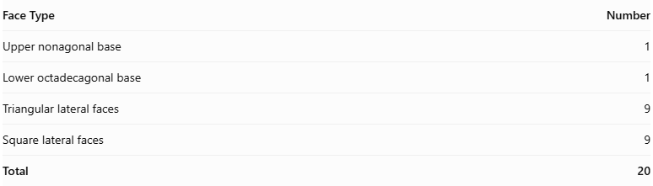
Face Type | Number
Upper nonagonal base | 1
Lower octadecagonal base | 1
Triangular lateral faces | 9
Square lateral faces | 9
Total | 20
The lateral faces alternate around the solid:
- 9 triangular faces.
- 9 square faces.
Important: A regular nonagonal cupola is a geometric cupola arrangement, but it cannot have all its lateral triangles equilateral and all its quadrilaterals square simultaneously. Those regular Johnson-solid cupola conditions apply to the triangular, square, and pentagonal cupolas.
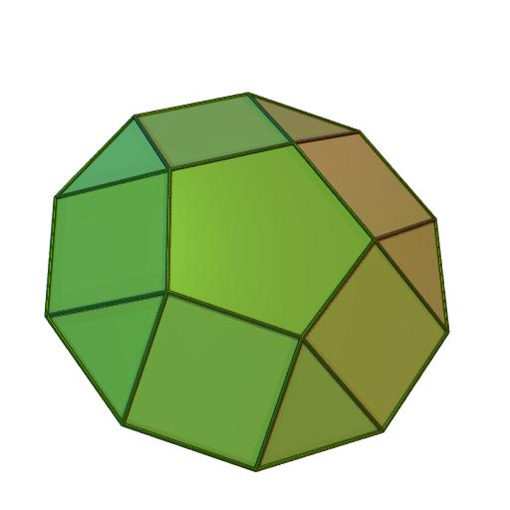

Edge Structure
# Source: AI Source: Provided by: [Data Path: Persons Table -> ID Column: 1, Name_En Column: Motasem Essam] -> From: [ChatGPT] on [7/25/2026]
A Nonagonal Cupola has 45 edges.
The edges are divided into three groups:
- 9 edges around the upper nonagonal base.
- 18 edges around the lower octadecagonal base.
- 18 connecting edges between the two bases.
Therefore:
$$E=9+18+18$$
$$\boxed{E=45}$$
Each edge is shared by exactly two faces.

Vertex Structure
# Source: AI Source: Provided by: [Data Path: Persons Table -> ID Column: 1, Name_En Column: Motasem Essam] -> From: [ChatGPT] on [7/25/2026]
A Nonagonal Cupola has 27 vertices:
- 9 vertices on the upper nonagonal base.
- 18 vertices on the lower octadecagonal base.
Each vertex is shared by exactly three faces in the standard cupola arrangement.
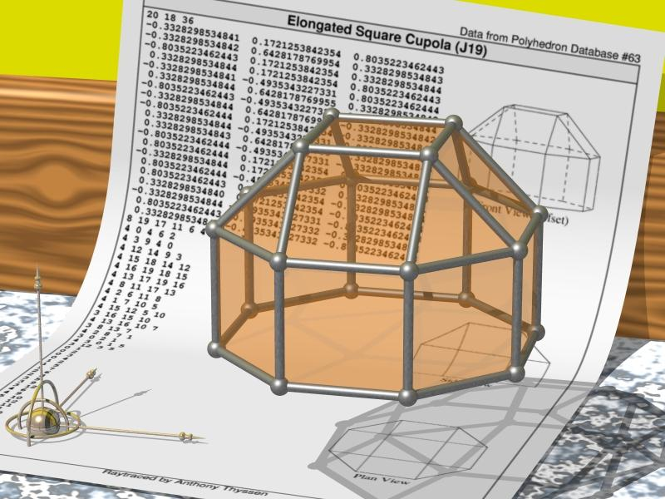

Mathematical Properties
# Source: AI Source: Provided by: [Data Path: Persons Table -> ID Column: 1, Name_En Column: Motasem Essam] -> From: [ChatGPT] on [7/25/2026]
For a general $n$-gonal cupola, the mathematical formulas are:
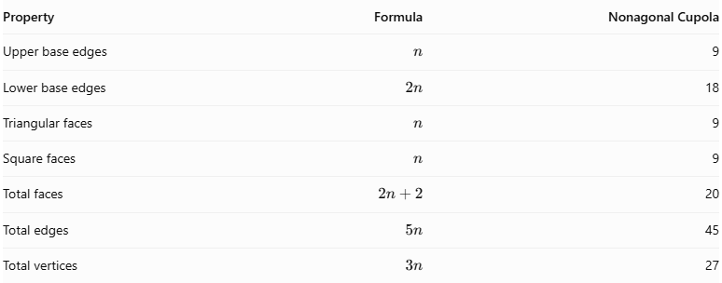
Property | Formula | Nonagonal Cupola
Upper base edges | $$n$$ | 9
Lower base edges | $$2n$$ | 18
Triangular faces | $$n$$ | 9
Square faces | $$n$$ | 9
Total faces | $$2n+2$$ | 20
Total edges | $$5n$$ | 45
Total vertices | $$3n$$ | 27
Euler's Formula
Every convex polyhedron satisfies:
$$V-E+F=2$$
Substituting:
$$27-45+20=2$$
$$\boxed{2=2}$$
Therefore, the Nonagonal Cupola satisfies Euler's formula.

Face Incidence
# Source: AI Source: Provided by: [Data Path: Persons Table -> ID Column: 1, Name_En Column: Motasem Essam] -> From: [ChatGPT] on [7/25/2026]
Face incidence describes how faces meet at the vertices.
In a standard Nonagonal Cupola:
- Each of the 9 upper vertices belongs to the upper nonagon and two lateral faces.
- Each of the 18 lower vertices belongs to the lower octadecagon and two lateral faces.
- Exactly 3 faces meet at every vertex.
Therefore, all 27 vertices are trivalent vertices.

Surface Area and Volume

Surface Area
# Source: AI Source: Provided by: [Data Path: Persons Table -> ID Column: 1, Name_En Column: Motasem Essam] -> From: [ChatGPT] on [7/25/2026]
The total surface area is the sum of the areas of both polygonal bases and all lateral faces.
$$S=A_{9}+A_{18}+9A_{t}+9A_{s}$$
Where:
- $A_{9}$ = Area of the upper regular nonagon.
- $A_{18}$ = Area of the lower regular octadecagon.
- $A_{t}$ = Area of one triangular lateral face.
- $A_{s}$ = Area of one square lateral face.
For a regular polygon with $m$ sides of length $a$:
$$A=\frac{{ma}^{2}}{4tan(π/m)}$$
The total surface area depends on the actual dimensions of the cupola.

Volume
# Source: AI Source: Provided by: [Data Path: Persons Table -> ID Column: 1, Name_En Column: Motasem Essam] -> From: [ChatGPT] on [7/25/2026]
The Nonagonal Cupola is a prismatoid. Its volume can be calculated using the prismatoid formula:
$$\boxed{V=\frac{h}{6}(A_{1}+4A_{m}+A_{2})}$$
Where:
- $h$ = Perpendicular distance between the base planes.
- $A_{1}$ = Area of the upper nonagonal cross-section.
- $A_{2}$ = Area of the lower octadecagonal base.
- $A_{m}$ = Area of the cross-section halfway between the bases.
A numerical volume requires the dimensions and relative positioning of the bases.

Symmetry
# Source: AI Source: Provided by: [Data Path: Persons Table -> ID Column: 1, Name_En Column: Motasem Essam] -> From: [ChatGPT] on [7/25/2026]
A standard symmetric Nonagonal Cupola has the following symmetry properties:
- Rotational Symmetry: Ninefold rotational symmetry around its central axis.
- Vertical Reflection Symmetry: 9 vertical reflection planes passing through the central axis.
- Horizontal Reflection Symmetry: Not generally present because the upper and lower bases have different numbers of sides.
- Central Symmetry: Not generally present.
Its symmetry group is:
$$\boxed{C_{9v}}$$

Relationship to Other Solids
# Source: AI Source: Provided by: [Data Path: Persons Table -> ID Column: 1, Name_En Column: Motasem Essam] -> From: [ChatGPT] on [7/25/2026]
The Nonagonal Cupola belongs to the family of $n$-gonal cupolas.
It is related to:
- Triangular Cupola: A triangular upper base and a hexagonal lower base.
- Square Cupola: A square upper base and an octagonal lower base.
- Pentagonal Cupola: A pentagonal upper base and a decagonal lower base.
- N-gonal Cupola: The general family with an $n$-sided upper base and a $2n$-sided lower base.
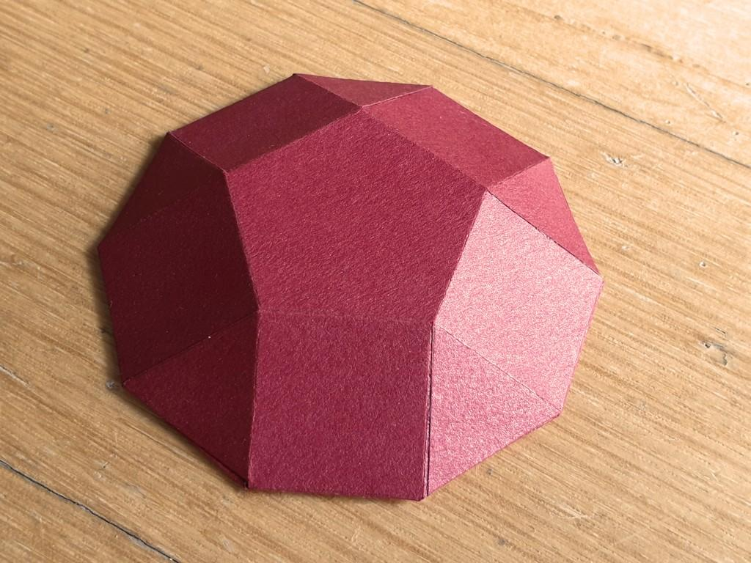
Pentagonal Cupola
5-sided upper base and 10-sided lower base.
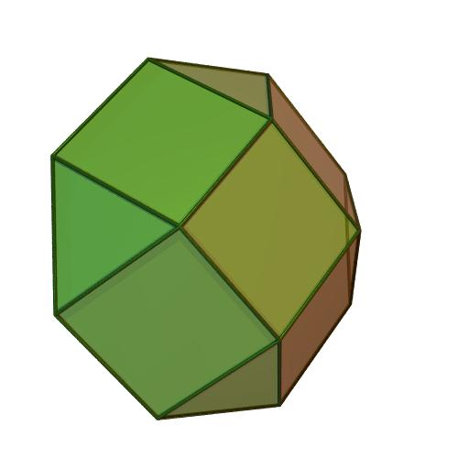
Nonagonal Cupola
9-sided upper base and 18-sided lower base.
The cupola is also a type of prismatoid, because its two polygonal bases lie in parallel planes.

Worked Example
# Source: AI Source: Provided by: [Data Path: Persons Table -> ID Column: 1, Name_En Column: Motasem Essam] -> From: [ChatGPT] on [7/25/2026]
Problem: Find the number of faces, edges, and vertices of a Nonagonal Cupola.
Solution:
Given:
$$n=9$$
Step 1: Calculate the number of faces.
$$F=2n+2$$
$$F=2(9)+2$$
$$\boxed{F=20}$$
Step 2: Calculate the number of edges.
$$E=5n$$
$$E=5(9)$$
$$\boxed{E=45}$$
Step 3: Calculate the number of vertices.
$$V=3n$$
$$V=3(9)$$
$$\boxed{V=27}$$
Final Answer:
- Faces = 20.
- Edges = 45.
- Vertices = 27.

Constructing Nonagonal Cupola in Solid Geometry

Geometric Instruments Used
# Source: AI Source: Provided by: [Data Path: Persons Table -> ID Column: 1, Name_En Column: Motasem Essam] -> From: [ChatGPT] on [7/25/2026]
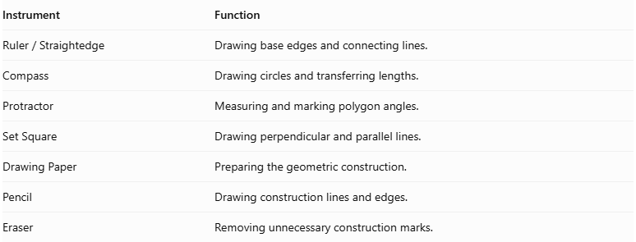
Instrument | Function
$$Ruler/Straightedge$$ | Drawing base edges and connecting lines.
Compass | Drawing circles and transferring lengths.
Protractor | Measuring and marking polygon angles.
Set Square | Drawing perpendicular and parallel lines.
Drawing Paper | Preparing the geometric construction.
Pencil | Drawing construction lines and edges.
Eraser | Removing unnecessary construction marks.

Instrument-Based Construction Procedures

Constructing the Lower Octadecagonal Base
# Source: AI Source: Provided by: [Data Path: Persons Table -> ID Column: 1, Name_En Column: Motasem Essam] -> From: [ChatGPT] on [7/25/2026]
- Draw a circle using a compass.
- Mark its center.
- Divide the circle into 18 equal angular sections.
- Each central angle measures:
$$\frac{{360}^{°}}{18}={20}^{°}$$
- Mark the 18 points around the circumference.
- Connect consecutive points using a ruler.
- Complete the regular octadecagon.
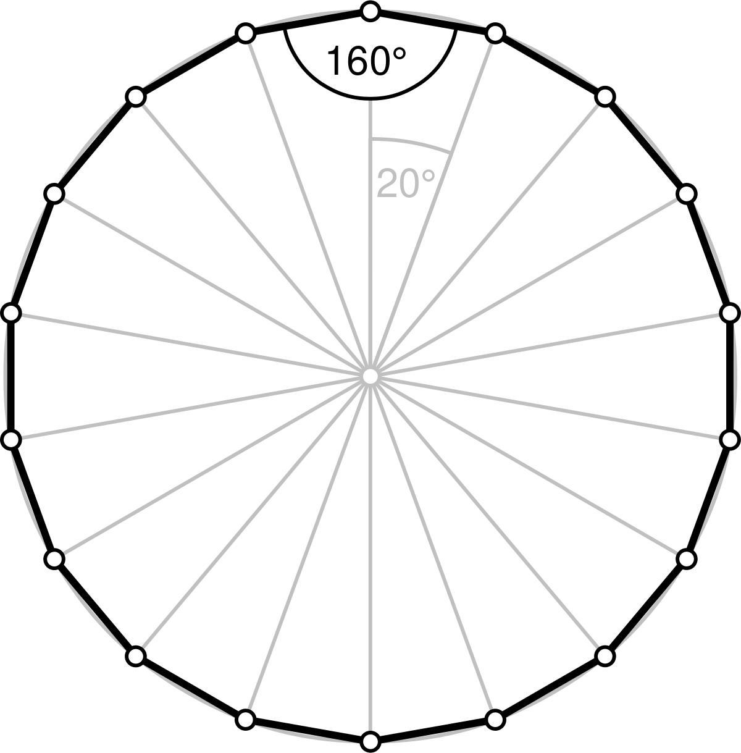

Constructing the Upper Nonagonal Base
# Source: AI Source: Provided by: [Data Path: Persons Table -> ID Column: 1, Name_En Column: Motasem Essam] -> From: [ChatGPT] on [7/25/2026]
- Draw a second circle with a compass.
- Mark its center.
- Divide the circle into nine equal angular sections.
- Each central angle measures:
$$\frac{{360}^{°}}{9}={40}^{°}$$
- Mark the nine points around the circumference.
- Connect consecutive points using a ruler.
- Complete the regular nonagon.
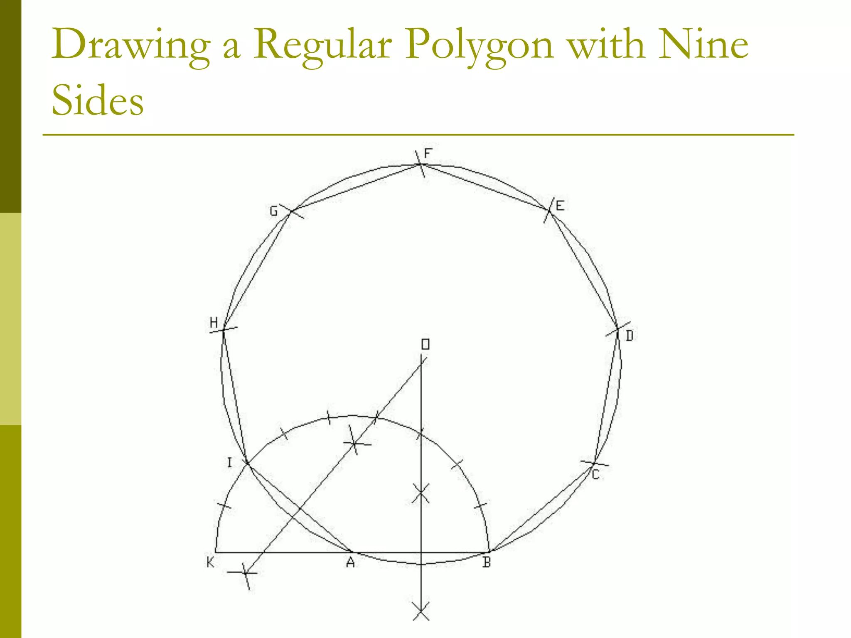

Positioning the Two Bases
# Source: AI Source: Provided by: [Data Path: Persons Table -> ID Column: 1, Name_En Column: Motasem Essam] -> From: [ChatGPT] on [7/25/2026]
- Draw the lower octadecagon.
- Draw the upper nonagon above the lower base.
- Keep both polygonal bases parallel.
- Position the upper base so its vertices and the lower base edges follow the intended alternating cupola arrangement.
- Maintain the intended symmetry around the central axis.

Constructing the Triangular Faces
# Source: AI Source: Provided by: [Data Path: Persons Table -> ID Column: 1, Name_En Column: Motasem Essam] -> From: [ChatGPT] on [7/25/2026]
- Identify the nine corresponding triangular face positions.
- Connect the appropriate vertices of the upper and lower bases.
- Draw the edges that form nine triangular lateral faces.
- Check that each triangle shares its edges with the correct neighboring faces.

Constructing the Quadrilateral Faces
# Source: AI Source: Provided by: [Data Path: Persons Table -> ID Column: 1, Name_En Column: Motasem Essam] -> From: [ChatGPT] on [7/25/2026]
- Identify the nine positions between the triangular faces.
- Connect the remaining corresponding vertices and base-edge endpoints.
- Form nine quadrilateral lateral faces.
- Check that each quadrilateral joins the appropriate triangular faces and base edges.

Completing the Three-Dimensional Representation
# Source: AI Source: Provided by: [Data Path: Persons Table -> ID Column: 1, Name_En Column: Motasem Essam] -> From: [ChatGPT] on [7/25/2026]
- Review all lateral connections.
- Check that the upper and lower bases are connected into one closed polyhedral surface.
- Distinguish visible edges from hidden edges.
- Erase unnecessary construction lines.
- Add shading to distinguish the triangular and quadrilateral faces.

Key Points
# Source: AI Source: Provided by: [Data Path: Persons Table -> ID Column: 1, Name_En Column: Motasem Essam] -> From: [ChatGPT] on [7/25/2026]
- A Nonagonal Cupola has a 9-sided upper base.
- Its lower base has 18 sides.
- It has 9 triangular lateral faces.
- It has 9 quadrilateral lateral faces.
- It has 20 faces in total.
- It has 45 edges.
- It has 27 vertices.
- Every vertex is shared by 3 faces.
- It has ninefold rotational symmetry.
- It is a prismatoid.
- Its lateral faces are arranged in an alternating pattern.

Conclusion
# Source: AI Source: Provided by: [Data Path: Persons Table -> ID Column: 1, Name_En Column: Motasem Essam] -> From: [ChatGPT] on [7/25/2026]
The Nonagonal Cupola is a prismatoid characterized by a nonagonal upper base, an octadecagonal lower base, and an alternating arrangement of 9 triangular and 9 quadrilateral lateral faces.
It is an extension of the general cupola family to a nine-sided upper polygon and demonstrates how different polygonal structures can be combined to form complex three-dimensional solids.

